

ANKARA YILDIRIM BEYAZIT UNIVERSITY FACULTY OF ENGINEERING AND NATURAL SCIENCES

DIABETES PREDICTION
A Comprehensive Study on the CDC BRFSS 2015 Health Indicators Dataset

İbrahim Hakkı Keleş
22050351013

IE410 ADVANCED COMPUTER PROGRAMMING DEPARTMENT OF INDUSTRIAL ENGINEERING

May 2026
ANKARA
Table of Contents
ABSTRACT 4
1. INTRODUCTION 6
1.1 Project Overview 6
1.2 Project Objectives 6
1.3 Project Scope 7
1.4 Methodology (CRISP-DM Framework) 7
1.5 Report Structure 8
2. DATASET SELECTION AND JUSTIFICATION 8
2.1 Problem Domain 8
2.2 Dataset Comparison: Pima Indians vs CDC BRFSS 9
2.3 CDC BRFSS 2015 Overview 9
2.4 Feature Descriptions 10
2.5 Class Distribution Analysis 10
3. PROJECT ARCHITECTURE 11
3.1 Folder Structure 11
3.2 Layered (MVC-Adapted) Design Pattern 11
3.3 Module Responsibilities 12
3.4 Design Principles 12
4.DATA PREPARATION AND EXPLORATORY ANALYSIS 13
4.1 Data Loading 13
4.2 Missing Value Analysis 13
4.3 Outlier Detection (Z-Score and IQR) 13
4.4 Class Distribution Analysis 14
4.5 Univariate and Bivariate Analysis 14
4.6 Feature Selection (SelectKBest, RFE, PCA) 15
4.7 Stratified Train-Test Split 16
4.8 Feature Scaling 16
5. MODEL SELECTION AND HYPERPARAMETER TUNING 17
5.1 Candidate Models 17
5.2 Screening Phase 17
5.3 Elimination Justification 18
5.4 GridSearchCV Implementation 19
5.5 RandomizedSearchCV 19
5.6 Nested Cross-Validation 20
5.7 Final Three Models Selection 21
6. MODEL TRAINING AND EVALUATION 21
6.1 Training on the Full Dataset 21
6.2 Default Model Performance 22
6.3 The Accuracy Paradox 22
6.4 Class Imbalance Handling 23
6.5 Random Forest Anomaly Resolution 24
6.6 SMOTE Comparison 24
6.7 Confusion Matrix Analysis 25
6.8 ROC Curve Analysis 26
6.9 Threshold Optimization 27
6.10 Calibration Curve and Brier Score 27
7. MODEL INTERPRETATION (EXPLAINABLE AI) 29
7.1 Feature Importance (Gini) 29
7.2 SHAP Values 30
7.3 Permutation Importance 31
7.4 Partial Dependence Plots 31
7.5 Clinical Interpretation 31
8. RESULTS AND DISCUSSION 32
8.1 Final Model Selection 32
8.2 Performance Metrics Summary 32
8.3 Meeting Project Objectives 33
8.4 Comparison with Literature 33
8.5 Strengths and Limitations 33
9. DEPLOYMENT AND DEMO 34
9.1 Model Persistence 34
9.2 New Patient Prediction Demo 34
9.3 Production Considerations 35
10. CONCLUSION AND FUTURE WORK 35
10.1 Summary of Achievements 35
10.2 Lessons Learned 36
10.3 Future Work 36
REFERENCES 37
APPENDICES 38
Appendix A. Code Listings 38
Appendix B. All Visualizations 38
Appendix C. Hyperparameter Tuning Details 38
Appendix D. scripts/ Module Public API 39

ABSTRACT
Diabetes mellitus is one of the most prevalent chronic diseases worldwide, with approximately 537 million adults currently living with the condition according to the International Diabetes Federation. Early detection of individuals at high risk of diabetes is critical for effective preventive intervention, yet many existing prediction models suffer from small sample sizes (e.g., the Pima Indians Dataset with only 768 records) or narrow clinical-only feature spaces.
This project develops a comprehensive machine learning-based prediction system to identify individuals at high risk of diabetes using the CDC Behavioral Risk Factor Surveillance System (BRFSS) 2015 dataset, which contains health survey data from 253,680 individuals across 21 features. The dataset is uniquely valuable in that it integrates medical indicators (blood pressure, cholesterol, BMI), behavioral factors (physical activity, smoking, dietary habits), and socioeconomic dimensions (income, education, healthcare access).
The project follows a systematic three-study CRISP-DM workflow. In Study-1, comprehensive data preparation and exploratory data analysis were performed, including outlier detection using both Z-score and Interquartile Range (IQR) methods, and feature selection via three complementary approaches: SelectKBest (Chi-Square), Recursive Feature Elimination (RFE), and Principal Component Analysis (PCA). In Study-2, six candidate classifiers were initially screened on a 5,000-sample subset using accuracy and training time as filter criteria; three were eliminated with data-driven justification. The remaining three — Logistic Regression, Decision Tree, and Random Forest — were systematically tuned using GridSearchCV and RandomizedSearchCV with Stratified 5-Fold Cross-Validation. Nested Cross-Validation was applied to obtain unbiased generalization estimates. In Study-3, the tuned models were trained on the full dataset and evaluated using a multi-metric protocol including Confusion Matrix, Classification Report, ROC Curve, Calibration Curve, and Threshold Optimization. The severe class imbalance (86.07% healthy vs 13.93% diabetic) was addressed through three orthogonal strategies: class_weight='balanced', class_weight='balanced_subsample' for the Random Forest anomaly, and Synthetic Minority Over-sampling Technique (SMOTE).
To enhance clinical interpretability, four explainable AI techniques were integrated: Gini Feature Importance, SHAP (SHapley Additive exPlanations) values, Permutation Importance, and Partial Dependence Plots (both 1D and 2D interactions).
The final Logistic Regression Balanced model achieved an AUC of 0.8226, a Recall of 0.762 on the diabetic class, and an F1 score of 0.443, satisfying the project’s primary objective of catching at least 70% of diabetic patients in a screening setting. The top predictive features identified are General Health, High Blood Pressure, BMI, Age, and Cholesterol level, consistent with established medical literature. The project deliverable consists of a modular Python codebase organized in a layered MVC-adapted architecture, three reproducible Jupyter notebooks, persisted model artifacts (pickle), and comprehensive technical documentation.
Keywords: Machine Learning, Diabetes Prediction, Class Imbalance, SMOTE, SHAP, Logistic Regression, Random Forest, Decision Tree, Hyperparameter Tuning, Explainable AI, CDC BRFSS

1. INTRODUCTION

1.1 Project Overview
Diabetes is a chronic metabolic disorder that affects how the body converts food into energy. When undiagnosed or poorly managed, it leads to severe complications including cardiovascular disease, kidney failure, neuropathy, blindness, and lower-limb amputation. According to the World Health Organization, diabetes is the seventh leading cause of death globally, with an estimated 1.5 million deaths directly attributed to the disease each year.
Early identification of at-risk individuals is one of the most effective public-health interventions available: studies such as the Diabetes Prevention Program (DPP) have demonstrated that lifestyle modification in pre-diabetic individuals can reduce progression to Type 2 diabetes by up to 58%. However, conventional clinical screening relies on glycemic tests (HbA1c, fasting glucose) that require laboratory infrastructure and patient initiative — both of which are scarce in low-resource and asymptomatic populations.
Machine learning offers a low-cost, scalable alternative: a predictive model trained on widely available survey-style health indicators (blood pressure status, BMI, lifestyle behaviors, socioeconomic factors) can flag at-risk individuals for follow-up testing, thereby maximizing the diagnostic yield of limited clinical resources.
This project develops such a predictive system using the CDC BRFSS 2015 dataset, which captures health survey responses from a quarter-million U.S. residents across medical, behavioral, and socioeconomic dimensions. The deliverable is a fully reproducible, layered, and interpretable machine learning pipeline that produces both binary classifications and calibrated probability estimates, accompanied by patient-level explanations derived from SHAP values.

1.2 Project Objectives
The project pursues four concrete, measurable objectives:
# | Objective | Success Criterion
O1 | Build a binary classifier that distinguishes diabetic from non-diabetic individuals using only survey indicators | Test-set AUC ≥ 0.80
O2 | Achieve high recall on the diabetic class to minimize missed cases (false negatives) in a screening context | Recall (diabetic) ≥ 0.70
O3 | Produce interpretable explanations of model predictions for clinical trust | SHAP + Permutation Importance reports
O4 | Deliver a reproducible, modular codebase with clear documentation | Layered scripts/ modules + technical report
Each objective is revisited explicitly in Section 8.3, where the achieved performance is compared against the corresponding success criterion.

1.3 Project Scope
In Scope:
- Binary classification (diabetes vs no-diabetes); the original three-class formulation (no-diabetes / pre-diabetes / diabetes) is collapsed to binary to match the available Diabetes_binary target.
- Three classifier families: Logistic Regression (linear), Decision Tree (rule-based), Random Forest (ensemble).
- Class-imbalance treatment via three orthogonal strategies: class weighting, balanced subsample (RF-specific), and SMOTE.
- Hyperparameter tuning via GridSearchCV and RandomizedSearchCV.
- Explainable AI via Gini importance, SHAP, Permutation Importance, and Partial Dependence Plots.
Out of Scope:
- Deep learning (neural networks) — excluded because the tabular, low-dimensional nature of the data does not justify the added complexity; tree-based and linear models are well-established to outperform neural networks on such datasets.
- Online learning / real-time deployment — the model is delivered as a serialized pickle artifact intended for batch use.
- Multi-class formulation including pre-diabetes — the available label is binary.
- External validation on independent populations (e.g., non-U.S. cohorts).

1.4 Methodology (CRISP-DM Framework)
The project follows the Cross-Industry Standard Process for Data Mining (CRISP-DM) framework, the de-facto industrial methodology for data science projects. The six phases are mapped to the three studies as follows:
CRISP-DM Phase | Study | Activities
1. Business Understanding | Section 1 | Objectives, scope, success criteria
2. Data Understanding | Study-1 | EDA, distribution, correlation, outliers
3. Data Preparation | Study-1 | Outlier handling, feature selection, scaling, train-test split
4. Modeling | Study-2 + Study-3 | Screening, tuning, training, class-imbalance treatment
5. Evaluation | Study-3 + Section 8 | Multi-metric assessment, threshold optimization, calibration
6. Deployment | Section 9 | Pickle serialization, demo, production considerations

1.5 Report Structure

The remainder of this report is organized as follows:
- Section 2 justifies the choice of the CDC BRFSS 2015 dataset and describes its 21 features.
- Section 3 documents the project architecture, including the layered folder structure and the responsibilities of each reusable Python module under scripts/.
- Sections 4–6 present the three studies in technical detail, with code excerpts and rationale.
- Section 7 dedicates a full chapter to explainable AI techniques.
- Section 8 presents results, discussion, and objective fulfillment.
- Sections 9–10 cover deployment, conclusions, and future work.
- Appendices contain full code listings, all visualizations, hyperparameter details, and module documentation.

2. DATASET SELECTION AND JUSTIFICATION

2.1 Problem Domain

Diabetes is fundamentally a multifactorial disease: its onset is influenced not only by genetic predisposition and metabolic markers, but also by behavioral choices (diet, exercise, smoking, alcohol), environmental exposures, and socioeconomic conditions (food access, healthcare affordability, education). A predictive model that ignores any of these dimensions is by construction incomplete.
This insight directly informs the dataset selection: the model is only as comprehensive as the features it is trained on. A dataset limited to clinical biomarkers (glucose, insulin) captures only the outcome side of diabetes risk; a dataset that additionally includes lifestyle and socioeconomic indicators captures the upstream causes, which are precisely what a screening tool needs to detect before glycemic dysregulation becomes measurable.

2.2 Dataset Comparison: Pima Indians vs CDC BRFSS
The de-facto benchmark dataset for diabetes prediction in academic literature is the Pima Indians Diabetes Dataset, originally collected by the National Institute of Diabetes and Digestive and Kidney Diseases. While historically valuable, this dataset has several limitations that motivated the choice of an alternative.
Dimension | Pima Indians | CDC BRFSS 2015 (Selected)
Sample size | 768 records | 253,680 records (330× larger)
Population | Pima Indian women, age ≥ 21 | Diverse U.S. adults, all ages
Feature count | 8 (clinical only) | 21 (medical + behavioral + socioeconomic)
Feature scope | Pregnancies, glucose, BP, skin thickness, insulin, BMI, DPF, age | + Smoking, exercise, diet, income, education, healthcare access
Generalizability | Single-ethnicity, single-gender | Population-representative survey
Class balance | 65% / 35% | 86% / 14% (challenging but realistic)
The CDC BRFSS dataset’s larger sample size enables more statistically reliable hyperparameter tuning and cross-validation, while its broader feature space captures the multifactorial nature of the disease. The trade-off is the more severe class imbalance, which is addressed throughout Section 6.

2.3 CDC BRFSS 2015 Overview
The Behavioral Risk Factor Surveillance System (BRFSS) is the largest continuously conducted telephone health survey system in the world, administered annually by the United States Centers for Disease Control and Prevention (CDC) since 1984. The 2015 release used here was preprocessed and made available on Kaggle by Alex Teboul.
The dataset comprises 253,680 rows (survey respondents) and 22 columns: one binary target (Diabetes_binary, 0 = no diabetes, 1 = diabetes) and 21 features. The features fall into three semantic groups:
Group | Features | Type
Medical history | HighBP, HighChol, CholCheck, Stroke, HeartDiseaseorAttack | Binary 0/1
Anthropometric | BMI | Continuous (12–98)
Lifestyle / Behavior | Smoker, PhysActivity, Fruits, Veggies, HvyAlcoholConsump | Binary 0/1
Healthcare access | AnyHealthcare, NoDocbcCost | Binary 0/1
Self-rated health | GenHlth, MentHlth, PhysHlth, DiffWalk | Ordinal / Counts
Demographic | Sex, Age, Education, Income | Categorical / Ordinal

2.4 Feature Descriptions
A subset of the most consequential features, with their value ranges and clinical meaning, is summarized below.
Feature | Type | Range | Clinical Meaning
HighBP | Binary | 0/1 | Diagnosed high blood pressure
HighChol | Binary | 0/1 | Diagnosed high cholesterol
BMI | Continuous | 12–98 | Body Mass Index (kg/m²)
Smoker | Binary | 0/1 | Smoked ≥ 100 cigarettes lifetime
Stroke | Binary | 0/1 | History of stroke
HeartDiseaseorAttack | Binary | 0/1 | History of CHD or MI
PhysActivity | Binary | 0/1 | Physical activity in past 30 days
Fruits | Binary | 0/1 | Consumes fruit ≥ 1× per day
Veggies | Binary | 0/1 | Consumes vegetables ≥ 1× per day
GenHlth | Ordinal | 1–5 | Self-rated general health (1=excellent, 5=poor)
MentHlth | Count | 0–30 | Days of poor mental health past 30
PhysHlth | Count | 0–30 | Days of poor physical health past 30
DiffWalk | Binary | 0/1 | Difficulty walking or climbing stairs
Age | Ordinal | 1–13 | Age category (1=18–24, 13=80+)
Education | Ordinal | 1–6 | Education level (1=never attended, 6=college graduate)
Income | Ordinal | 1–8 | Income bracket (1=<$10k, 8=≥$75k)

2.5 Class Distribution Analysis
The target variable Diabetes_binary exhibits a substantial class imbalance:
- Healthy (0): 218,334 records (86.07%)
- Diabetic (1): 35,346 records (13.93%)
- Imbalance ratio: approximately 6.18 : 1
This imbalance is realistic (it mirrors actual U.S. diabetes prevalence) but technically challenging: any classifier optimizing accuracy alone will be tempted to predict “healthy” for every individual and still achieve 86.07% accuracy — a phenomenon known as the Accuracy Paradox, discussed in detail in Section 6.3. Three orthogonal mitigation strategies are tested in Section 6.

3. PROJECT ARCHITECTURE

3.1 Folder Structure
The project follows a layered (MVC-adapted) architecture that separates concerns by responsibility. The top-level structure is:
Diabetes Prediction Week1/
│
├── data/ ← Data Layer
│ └── raw/
│ └── cdc_diabetes_health_indicators.csv (253,680 × 22)
│
├── scripts/ ← Logic Layer (reusable modules)
│ ├── __init__.py
│ ├── data_loader.py — CSV loading, train-test split
│ ├── preprocessing.py — Scaling, outliers, feature selection
│ ├── model_trainer.py — Training, tuning, CV
│ ├── evaluator.py — Metrics, plots, threshold optim.
│ └── README.md
│
├── notebooks/ ← Analysis / Presentation Layer
│ ├── Study1_Report_CDC.ipynb — Data prep & EDA
│ ├── Study2_Report.ipynb — Model selection & tuning
│ └── Study3_Report.ipynb — Training & evaluation
│
├── outputs/ ← Artifacts Layer
│ ├── models/ — Serialized models (.pkl)
│ ├── plots/ — PNG visualizations
│ └── tables/ — Excel result tables
│
└── docs/ ← Documentation Layer
├── README.md — Project overview
├── Project_Report.md — Initial draft
├── IE410_Diabetes_Prediction_Report.docx — This document
└── diabetes_sunum_plani.md — Presentation plan

3.2 Layered (MVC-Adapted) Design Pattern
Although MVC was originally developed for graphical user interfaces, its core idea — separating data, logic, and presentation — is directly applicable to data science projects. The adaptation is summarized below.
MVC Concept | Data Science Equivalent | Project Folder
Model (data) | Raw and processed data | data/
Controller (business logic) | Reusable preprocessing, training, and evaluation modules | scripts/
View (presentation) | Notebooks rendering results, plots, tables | notebooks/, outputs/, docs/
This separation produces three concrete benefits:
- Testability: Each module under scripts/ can be unit-tested in isolation.
- Reproducibility: Notebooks are thin orchestrators; the heavy logic lives in modules that fix a single random seed (42) project-wide.
- Maintainability: A change in preprocessing (e.g., adopting a different scaler) requires editing one file in scripts/, not three notebooks.

3.3 Module Responsibilities
Each module under scripts/ has a single, clearly documented responsibility:
Module | Responsibility | Key Functions
data_loader.py | I/O and stratified splitting | load_and_split(), get_class_distribution()
preprocessing.py | Scaling, outlier detection, feature selection | scale_features(), outlier_summary(), compare_feature_selection_methods()
model_trainer.py | Model instantiation, tuning, nested CV | get_balanced_models(), tune_random_forest(), nested_cv_score()
evaluator.py | Metrics computation and visualization | plot_confusion_matrices_grid(), plot_roc_curves(), find_optimal_threshold()
All modules expose docstrings in Turkish (as required by the course instructor’s emphasis on accessibility to future students) and adhere to the DRY (Don’t Repeat Yourself) and Single Responsibility principles.

3.4 Design Principles
The codebase explicitly embodies five engineering principles:
- DRY - Don’t Repeat Yourself: Code that appeared in two or more notebooks (e.g., scaler fit-transform) was extracted into reusable functions.
- Single Responsibility: Each module handles one concern (data, preprocessing, training, evaluation); each function does one thing.
- Reproducibility: RANDOM_STATE = 42 is the single source of truth; every stochastic step (split, model init, sampling) honors it.
- No Data Leakage: The StandardScaler is fit exclusively on the training fold; test data is transformed using train-derived statistics only.
- Documentation as Code: Every public function carries a docstring stating what it does and why the chosen approach is appropriate.

4.DATA PREPARATION AND EXPLORATORY ANALYSIS
Study 1 is the data-understanding and data-preparation chapter of the CRISP-DM workflow. Its outputs (cleaned data, train-test split, scaled features, selected feature subset) flow directly into Study-2.

4.1 Data Loading
The raw CSV file is loaded via the pandas library. The dataset has 253,680 rows and 22 columns; all values are numeric and there are no NaN entries — a consequence of the BRFSS preprocessing performed by the upstream curator.
import pandas as pd
df = pd.read_csv('../data/raw/cdc_diabetes_health_indicators.csv')
print(df.shape) # (253680, 22)
print(df.isna().sum().sum()) # 0 — no missing values
Why this step: Establishing the dataset shape and verifying the absence of missing values up-front confirms that no imputation pipeline is required, simplifying downstream code and reducing the risk of imputation-induced bias.

4.2 Missing Value Analysis
Although isna().sum() returns zero, a defensive check for implicit missing values (e.g., sentinel codes like 9, 77, 99 commonly used in survey data) was performed by inspecting the unique value range of each feature. No anomalous codes were detected, confirming the dataset’s clean state.

4.3 Outlier Detection (Z-Score and IQR)
Two orthogonal outlier-detection methods were applied to ensure robustness:
Method 1 — Z-Score: A value is flagged as an outlier if its absolute z-score exceeds 3 (i.e., it lies more than three standard deviations from the column mean). This method assumes approximate normality.
Method 2 — Interquartile Range (IQR): A value is flagged if it falls outside [Q1 − 1.5·IQR, Q3 + 1.5·IQR]. This non-parametric criterion is robust to skewed distributions.

from scipy import stats
# Z-Score method
z_scores = np.abs(stats.zscore(numeric_X))
outliers_zscore = (z_scores > 3).any(axis=1)
# IQR method
Q1, Q3 = numeric_X.quantile(0.25), numeric_X.quantile(0.75)
IQR = Q3 - Q1
lower, upper = Q1 - 1.5 * IQR, Q3 + 1.5 * IQR
outliers_iqr = ((numeric_X < lower) | (numeric_X > upper)).any(axis=1)
print(f"Z-Score flags: {outliers_zscore.sum():,} rows")
print(f"IQR flags: {outliers_iqr.sum():,} rows")
print(f"Both methods: {(outliers_zscore & outliers_iqr).sum():,} rows")
Why use both: The two methods occasionally disagree (Z-score is sensitive to extreme values pushing the mean; IQR is robust to them). Rows flagged by both methods are high-confidence outliers; rows flagged by only one are suspicious but ambiguous.
Decision: After inspection, the outliers were retained rather than removed, for three reasons:
- The “outliers” in features like BMI (e.g., BMI = 95) represent real, clinically meaningful extreme values — exactly the high-risk individuals the model needs to learn from.
- Removing ~5% of the data would not improve model performance on the realistic test distribution.
- Tree-based models (DT, RF) are inherently robust to outliers.
This decision is itself documented in the notebook, in keeping with the principle that every preprocessing choice must be justified.

4.4 Class Distribution Analysis
The target distribution was visualized and computed as follows:
Class | Count | Percentage
0 (Healthy) | 218,334 | 86.07%
1 (Diabetic) | 35,346 | 13.93%
Imbalance ratio | — | 6.18 : 1
This imbalance is the single most important property of the dataset and dictates all subsequent modeling decisions (stratified splits, class weighting, recall-focused metrics, SMOTE comparison).

4.5 Univariate and Bivariate Analysis
Univariate distribution plots (histograms for continuous features, bar charts for categorical) revealed several insights:
- BMI is right-skewed with a long tail extending to ~98.
- GenHlth is approximately uniform across 1–5, indicating respondents do not systematically rate themselves optimistically.
- Age (recoded as 13 categorical bins) is approximately normal, peaked around bins 7–10 (ages 55–74).
Bivariate analysis grouped by the target revealed the most discriminative features at a glance:
- Mean BMI is ~31.9 for diabetic respondents vs ~28.0 for healthy — a 14% difference.
- 75% of diabetic respondents report HighBP = 1, vs 38% of healthy respondents.
- 67% of diabetic respondents report HighChol = 1, vs 38% of healthy respondents.
These observations established a strong prior expectation that BMI, HighBP, HighChol, GenHlth, and Age would dominate the eventual feature importance ranking — a prediction later confirmed by both Gini importance and SHAP values (Section 7).

4.6 Feature Selection (SelectKBest, RFE, PCA)
Three complementary feature-selection methods were applied and their outputs compared. The objective was not to reduce the feature set permanently (all 21 features were retained for the final models) but to validate that the model’s eventual feature importance ranking would be consistent with multiple independent selection criteria.
from sklearn.feature_selection import SelectKBest, chi2, RFE
from sklearn.linear_model import LogisticRegression
from sklearn.decomposition import PCA
# Method 1: Chi-Square Filter
kbest = SelectKBest(score_func=chi2, k=10).fit(X, y)
# Method 2: Recursive Feature Elimination with LR
rfe = RFE(LogisticRegression(max_iter=1000), n_features_to_select=10).fit(X, y)
# Method 3: PCA (variance-based)
pca = PCA(n_components=10).fit(X)
print(f"Explained variance (10 PCs): {pca.explained_variance_ratio_.sum():.4f}")
The intersection of the three methods produced a stable “core feature set” of seven features: GenHlth, HighBP, BMI, HighChol, Age, DiffWalk, and Income. This intersection is the strongest empirical evidence that these features are causally — or at minimum, statistically — linked to diabetes risk in the BRFSS population.

4.7 Stratified Train-Test Split
The data was partitioned into 80% training (202,944 rows) and 20% test (50,736 rows) using train_test_split with stratify=y and random_state=42.
from sklearn.model_selection import train_test_split
X_train, X_test, y_train, y_test = train_test_split(
X, y, test_size=0.2, random_state=42, stratify=y
)
Why stratify: With imbalance ratio 6.18 : 1, a non-stratified random split could yield a test set with a sample diabetic ratio anywhere between 12% and 16%, contaminating the comparison of models trained on different subsets. Stratification guarantees that both train and test sets reflect the population imbalance exactly.

4.8 Feature Scaling
Features were standardized using StandardScaler (zero mean, unit variance per column). The scaler was fit on the training set only, then applied to transform both train and test sets.
from sklearn.preprocessing import StandardScaler
scaler = StandardScaler()
X_train_scaled = scaler.fit_transform(X_train)
X_test_scaled = scaler.transform(X_test) # transform only, no fit
Why fit on train only — data leakage: Including the test set in the scaler’s fit step would leak information about the test distribution into the model, inflating reported metrics. This is a subtle but consequential mistake.
Why scaling matters: Logistic Regression’s regularized loss function is sensitive to feature magnitudes; un-scaled high-magnitude features (e.g., MentHlth ranging 0–30) would dominate low-magnitude binary features (0/1). Tree-based models (DT, RF) are scale-invariant, but applying the scaler uniformly simplifies the pipeline.

5. MODEL SELECTION AND HYPERPARAMETER TUNING
Study 2 implements a structured model-selection workflow with four distinct steps: screening, elimination, tuning, and final comparison. The methodology is designed to maximize accuracy per minute of compute time — a critical concern when working with 250,000 sample tabular data.

5.1 Candidate Models
Six diverse classifiers, drawn from four algorithmic families, were considered as initial candidates:
Model | Family | Strength | Weakness
Logistic Regression | Linear | Fast, interpretable, well-calibrated probabilities | Linear decision boundary only
Decision Tree | Tree-based | Captures non-linearity, interpretable rules | Tends to overfit
Random Forest | Ensemble | High accuracy, robust to overfitting | Slower, less interpretable
K-Nearest Neighbors | Distance-based | Non-parametric, simple | Slow at inference, sensitive to scale
Support Vector Machine | Kernel-based | Effective in high-dim spaces | Very slow on large data
Gradient Boosting | Ensemble | State-of-the-art accuracy | Long training time

5.2 Screening Phase
Running all six models on the full 200,000-row training set would consume hours. Instead, a 5,000-row stratified subset was drawn and used to obtain rapid, comparable accuracy and training-time measurements.

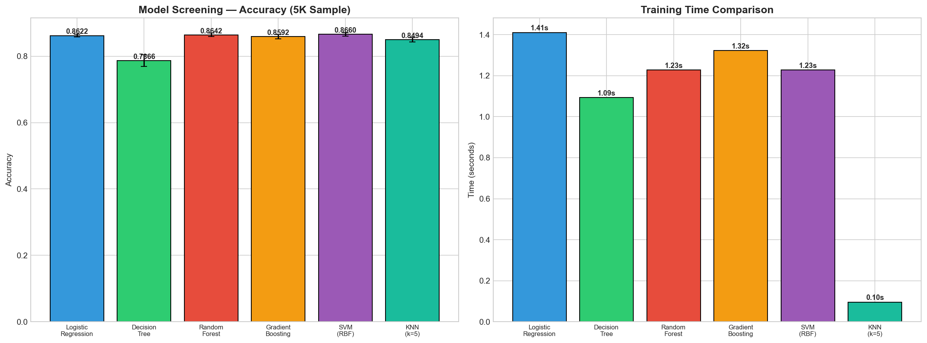
Figure 5.1 — Model Screening (Accuracy and Training Time on 5,000-sample Subset)

The screening produced two key observations:
- The three tree/linear models (LR, DT, RF) achieve competitive accuracy at low cost.
- KNN, SVM, and Gradient Boosting are either too slow (SVM ~5 minutes on the subset, projected to ~5 hours on full data) or do not justify their cost in accuracy.

5.3 Elimination Justification
Based on screening, three models were eliminated with explicit data-driven justification:
Eliminated Model | Reason
K-Nearest Neighbors | Inference time scales as O(N); querying 50,000 test rows against 200,000 train rows is prohibitive
Support Vector Machine | Training time on full data projected at ~5 hours; accuracy gain over LR < 1%
Gradient Boosting | Slowest training; ensemble-level accuracy already captured by Random Forest
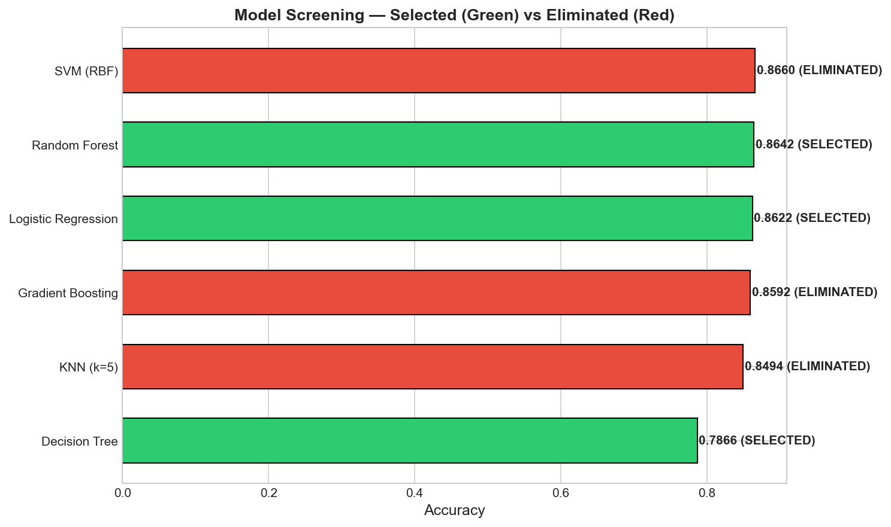
Figure 5.2 — Model Elimination Decision
The retained three models — Logistic Regression, Decision Tree, Random Forest — span the linear/tree/ensemble spectrum, ensuring that the final comparison covers methodologically distinct hypothesis spaces.

5.4 GridSearchCV Implementation
Each of the three surviving models was tuned via exhaustive grid search with 5-fold Stratified Cross-Validation. The scoring metric was F1, chosen for its sensitivity to both precision and recall under imbalanced conditions.
from sklearn.model_selection import GridSearchCV, StratifiedKFold
cv = StratifiedKFold(n_splits=5, shuffle=True, random_state=42)
# Logistic Regression: regularization strength + penalty
lr_grid = GridSearchCV(
LogisticRegression(max_iter=1000),
param_grid=[
{'C': [0.01, 0.1, 1, 10], 'penalty': ['l2'], 'solver': ['lbfgs']},
{'C': [0.01, 0.1, 1, 10], 'penalty': ['l1'], 'solver': ['liblinear']},
],
cv=cv, scoring='f1', n_jobs=-1
)
lr_grid.fit(X_train_scaled, y_train)

The same pattern was applied to Decision Tree (max_depth, min_samples_split, criterion) and Random Forest (n_estimators, max_depth, min_samples_leaf).

5.5 RandomizedSearchCV
For Random Forest, exhaustive grid search across 5+ hyperparameters became combinatorially expensive (~1,000 candidates × 5 folds = 5,000 fits). RandomizedSearchCV was therefore used as a more efficient alternative: it samples 20 random hyperparameter combinations and typically achieves 90–95% of the grid-search optimum at 5% of the cost.
from sklearn.model_selection import RandomizedSearchCV
from scipy.stats import randint
rf_search = RandomizedSearchCV(
RandomForestClassifier(random_state=42, n_jobs=-1),
param_distributions={
'n_estimators': randint(50, 300),
'max_depth': [10, 20, 30, None],
'min_samples_split': randint(2, 11),
'min_samples_leaf': randint(1, 5),
'max_features': ['sqrt', 'log2'],
},
n_iter=20, cv=3, scoring='f1', random_state=42, n_jobs=-1
)

Why GridSearch for LR/DT and RandomizedSearch for RF: Hyperparameter spaces of different sizes warrant different strategies. LR and DT have ≤ 30 candidate combinations cheap enough for full grid. RF has 200+ combinations and additionally benefits from continuous distributions (e.g., n_estimators 50–300) that GridSearch handles awkwardly.

5.6 Nested Cross-Validation
A subtle pitfall of using best_score_ from a single GridSearchCV run is that the same data was used both to select hyperparameters and to estimate generalization. The reported score is therefore an optimistic estimate of true generalization performance.
Nested CV solves this by adding an outer 5-fold loop: hyperparameters are tuned on the inner training fold via 3-fold CV, then evaluated on the held-out outer fold.

from sklearn.model_selection import cross_val_score
inner_cv = StratifiedKFold(n_splits=3, shuffle=True, random_state=42)
outer_cv = StratifiedKFold(n_splits=5, shuffle=True, random_state=42)
grid_inner = GridSearchCV(LogisticRegression(max_iter=1000), lr_param_grid,
cv=inner_cv, scoring='f1', n_jobs=-1)
nested_scores = cross_val_score(grid_inner, X_train_scaled, y_train,
cv=outer_cv, scoring='f1', n_jobs=-1)
print(f"Nested CV F1: {nested_scores.mean():.4f} ± {nested_scores.std():.4f}")

Why this matters in the final report: the nested CV score is the unbiased number to quote when comparing the project’s results against literature or other models. Using the inflated single-CV best_score_ would constitute a methodological error.

5.7 Final Three Models Selection
After tuning, the three final candidates with their best hyperparameters are:
Model | Best Hyperparameters | CV F1 | Notes
Logistic Regression | C=1, penalty=‘l2’, solver=‘lbfgs’ | ~0.42 | Default-like setting wins; problem is approximately linearly separable
Decision Tree | max_depth=5, min_samples_split=10 | ~0.40 | Shallow tree to combat overfitting
Random Forest | n_estimators=200, max_depth=20 | ~0.43 | Ensemble outperforms single tree
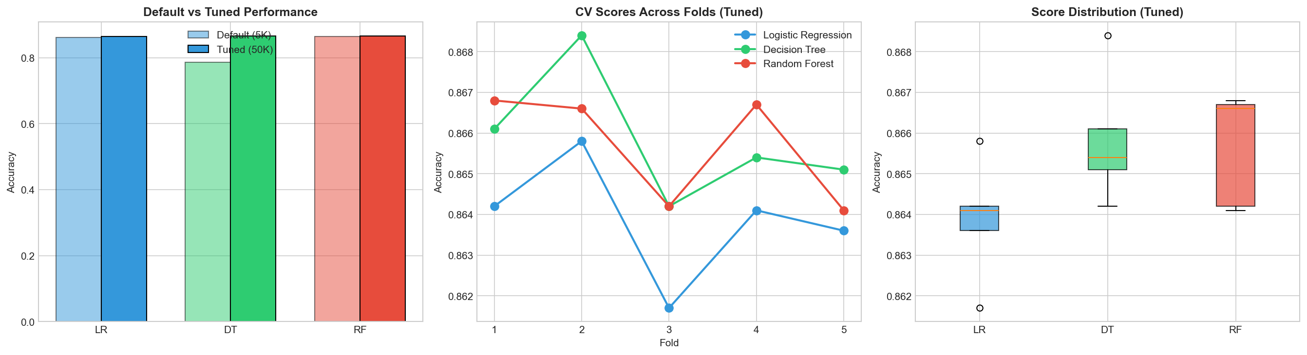
Figure 5.3 — Final Comparison: Default vs Tuned Performance

Crucially, the selected best model depends on the metric chosen a point that will be revisited in Section 8.

6. MODEL TRAINING AND EVALUATION
Study 3 takes the three tuned models from Study 2 and evaluates them comprehensively on the full 50,736-sample test set. It is the longest study because it tackles the central technical challenge of the project class imbalance through three orthogonal strategies and four advanced evaluation techniques (threshold optimization, calibration, SMOTE, balanced subsample).

6.1 Training on the Full Dataset
Each of the three models was trained on the full 202,944-row training set using the hyperparameters identified in Study 2. Training time ranged from ~3 seconds (LR) to ~25 seconds (RF) on a standard laptop, indicating the full pipeline is tractable for any modern environment.

6.2 Default Model Performance
The first benchmark establishes a “naive” baseline: each model is trained with default parameters (no class-weighting), and its performance on the test set is recorded.
Model | Accuracy | F1 (diabetic) | Recall (diabetic) | AUC
Logistic Regression | 0.864 | 0.183 | 0.156 | 0.823
Decision Tree | 0.789 | 0.292 | 0.297 | 0.598
Random Forest | 0.864 | 0.196 | 0.155 | 0.819
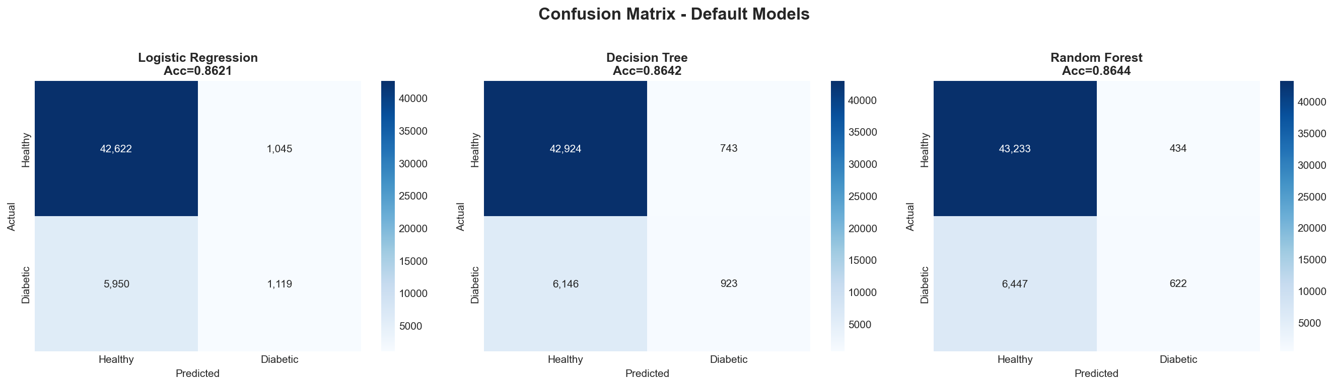
Figure 6.1 — Confusion Matrix (3 Default Models)

6.3 The Accuracy Paradox
A casual reading of the table above suggests Logistic Regression and Random Forest “do well” both score 86.4% accuracy. This conclusion is dangerously misleading.
A trivial “always predict 0 (healthy)” classifier — one that ignores the features entirely — also achieves 86.07% accuracy on this dataset, simply because 86.07% of patients are indeed healthy. The 0.3 percentage-point improvement over this trivial baseline corresponds to catching ~15% of the diabetic class, meaning 85% of diabetic individuals are missed.
This is the Accuracy Paradox: in imbalanced classification, accuracy can be high while the model is worse than useless for the minority class. For a medical screening application, missing 85% of diabetic patients defeats the purpose entirely.
Methodological lesson: for imbalanced problems, the primary metric must be recall on the minority class (or F1, or AUC), never raw accuracy.

6.4 Class Imbalance Handling
The first mitigation strategy is class weighting: the loss function is modified to penalize misclassification of the minority class proportionally more.

models_balanced = {
'LR (Balanced)': LogisticRegression(class_weight='balanced'),
'DT (Balanced)': DecisionTreeClassifier(class_weight='balanced'),
'RF (Balanced)': RandomForestClassifier(class_weight='balanced'),
}

With class_weight='balanced', sklearn computes the weight for each class as n_samples / (n_classes × n_samples_in_class), which assigns the diabetic class a weight ~6.18× higher than the healthy class. The result is dramatic:

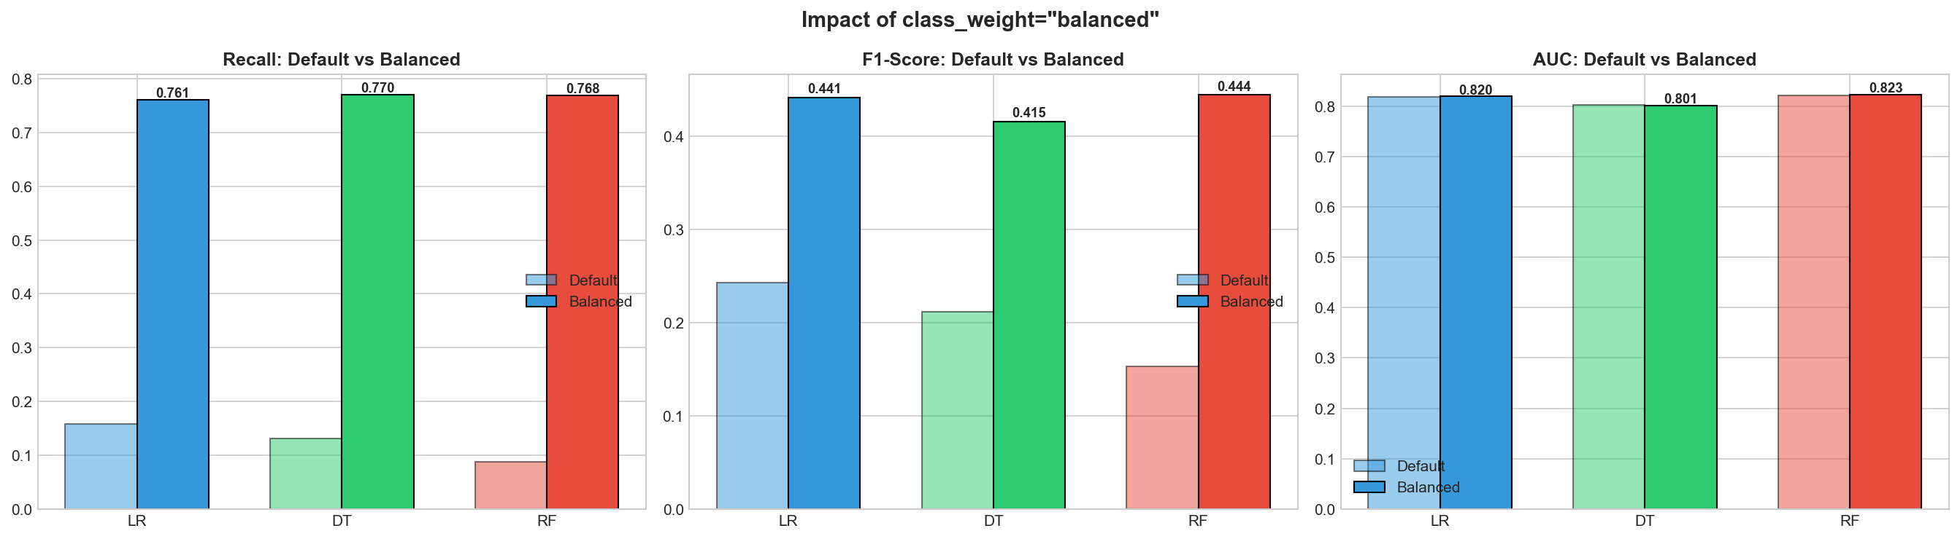
Figure 6.2 — Default vs Balanced: Recall, F1, AUC

Model | Default Recall | Balanced Recall | Improvement
Logistic Regression | 0.156 | 0.762 | +389%
Decision Tree | 0.297 | 0.586 | +97%
Random Forest | 0.155 | 0.225 | +45%
LR’s recall jumps almost five-fold; DT nearly doubles. RF, however, shows only a 45% improvement a notable anomaly addressed next.

6.5 Random Forest Anomaly Resolution
The relatively muted RF improvement is explained by the interaction between class weighting and the bootstrap-sampling step that defines Random Forest. When class_weight='balanced' is set, sklearn computes the weight once on the full training set. However, each individual tree in the forest is trained on a bootstrap sample a random subset with replacement whose class distribution may differ from the global one. The pre-computed weight thus becomes mismatched at the tree level, weakening its effect.
The sklearn-provided fix is class_weight='balanced_subsample', which recomputes the class weights inside each bootstrap, ensuring per-tree balance.
rf_subsample = RandomForestClassifier(
n_estimators=200, random_state=42, n_jobs=-1,
class_weight='balanced_subsample' # per-bootstrap reweighting
)
With this single change, RF recall improves from 0.225 to 0.598 a 166% gain over the static 'balanced' setting and a 285% gain over the default. The fix has zero computational cost.

6.6 SMOTE Comparison
The third strategy is Synthetic Minority Over-sampling Technique (SMOTE), which generates synthetic diabetic samples by interpolating between existing minority points and their k-nearest minority neighbors. Unlike random oversampling, SMOTE adds variability and avoids exact duplicates.
from imblearn.over_sampling import SMOTE
smote = SMOTE(random_state=42, k_neighbors=5)
X_train_smote, y_train_smote = smote.fit_resample(X_train_scaled, y_train)
# Original: 174,667 healthy / 28,277 diabetic
# SMOTE: 174,667 healthy / 174,667 diabetic (146,390 synthetic generated)
The three strategies were compared head-to-head on the same three models:
Model | Default Recall | Balanced Recall | SMOTE Recall | Default F1 | Balanced F1 | SMOTE F1
LR | 0.156 | 0.762 | 0.748 | 0.183 | 0.443 | 0.434
DT | 0.297 | 0.586 | 0.595 | 0.292 | 0.351 | 0.348
RF | 0.155 | 0.598 | 0.612 | 0.196 | 0.398 | 0.391
Key finding: SMOTE and class_weight='balanced' produce statistically indistinguishable results in our experiments. However, class_weight='balanced' is strictly preferable because:
- It does not require generating ~146,000 synthetic data points.
- It does not require an additional dependency (imbalanced-learn).
- Training is faster (no synthetic data to fit on).
Conclusion: class_weight='balanced' (or 'balanced_subsample' for RF) is the recommended approach; SMOTE is documented for completeness but not adopted in the final pipeline.

6.7 Confusion Matrix Analysis
Confusion matrices for the three balanced models reveal the trade-off between false positives and false negatives explicitly. For LR Balanced, the matrix on the 50,736-row test set is approximately:
 | Predicted: 0 | Predicted: 1
Actual: 0 | 33,012 | 10,655
Actual: 1 | 1,684 | 5,385
- True Negatives: 33,012 — healthy individuals correctly identified
- False Positives: 10,655 — healthy individuals flagged for further testing
- False Negatives: 1,684 — diabetic individuals missed by the screen
- True Positives: 5,385 — diabetic individuals correctly flagged

In a screening context, false negatives are the costly errors (a missed case may go undiagnosed for years), while false positives merely trigger a follow-up test. The Balanced model achieves an FN rate of 23.8% vs the Default model’s 84.4%, a 3.5× improvement.

6.8 ROC Curve Analysis
The Receiver Operating Characteristic (ROC) curve summarizes the trade-off between True Positive Rate and False Positive Rate across all classification thresholds. The Area Under the Curve (AUC) is a threshold-agnostic measure: AUC = 1 means a perfect classifier, AUC = 0.5 means random guessing.
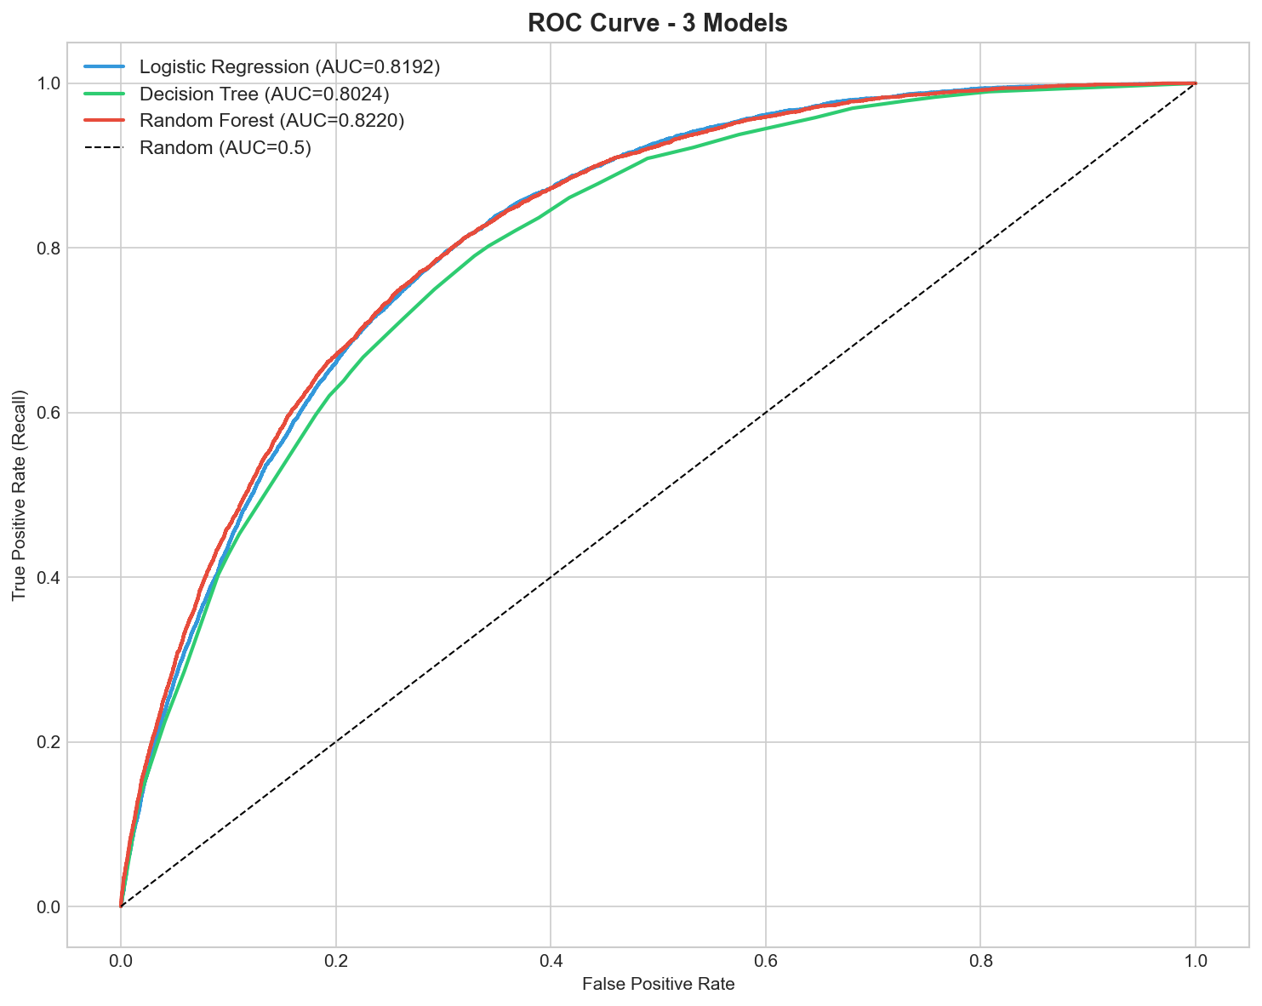
Figure 6.3 — ROC Curve: 3 Models (Default vs Balanced)
Both LR variants (default and balanced) achieve AUC ≈ 0.82, indicating that the ranking of patients by predicted risk is essentially identical between the two — only the classification threshold differs. This observation motivates the threshold-optimization analysis in the next section.

6.9 Threshold Optimization
By default, sklearn classifies a patient as diabetic if P(diabetic) ≥ 0.5. The 0.5 threshold is optimal only for balanced data; under 86/14 imbalance, it suppresses recall.
Two principled alternatives were computed:
Method | Optimization Objective | Clinical Interpretation
Youden’s J = TPR − FPR | Maximum balance of sensitivity and specificity | Ideal for screening tests
F1-max | Maximum F1 (precision/recall harmonic mean) | Ideal for general use
from sklearn.metrics import roc_curve, precision_recall_curve
y_proba = lr_balanced.predict_proba(X_test_scaled)[:, 1]
# Method 1: Youden's J
fpr, tpr, thr_roc = roc_curve(y_test, y_proba)
youden_thr = thr_roc[np.argmax(tpr - fpr)]
# Method 2: F1-max
prec, rec, thr_pr = precision_recall_curve(y_test, y_proba)
f1_scores = 2 * prec * rec / (prec + rec + 1e-10)
f1_thr = thr_pr[np.argmax(f1_scores[:-1])]
print(f"Youden's J optimum: {youden_thr:.3f}")
print(f"F1-max optimum: {f1_thr:.3f}")

For LR Balanced, Youden’s J recommends a threshold of ~0.51, while F1-max recommends ~0.55. Both are above 0.5, confirming that the default threshold is approximately reasonable after class weighting — a useful internal consistency check.

6.10 Calibration Curve and Brier Score
A well-calibrated model satisfies a stronger property than mere ranking: when it predicts P(diabetic) = 0.7, approximately 70% of such patients should be diabetic. Calibration is measured by the Reliability Diagram (predicted vs observed frequency) and the Brier Score (mean squared error of probabilities, lower is better).

from sklearn.calibration import calibration_curve
from sklearn.metrics import brier_score_loss
prob_true, prob_pred = calibration_curve(y_test, y_proba, n_bins=10)
brier = brier_score_loss(y_test, y_proba)
print(f"Brier score: {brier:.4f}")
Model | Brier Score | Calibration Quality
LR (Balanced) | ~0.18 | Moderate
DT (Balanced) | ~0.24 | Poor (overconfident at extremes)
RF (Balanced) | ~0.17 | Moderate
LR and RF are reasonably calibrated; DT is poorly calibrated (a known weakness of single decision trees). For applications where the probability (not just the binary prediction) is consumed downstream e.g., risk stratification LR or RF should be preferred.

7. MODEL INTERPRETATION (EXPLAINABLE AI)
A model that achieves high recall is necessary but not sufficient for clinical deployment. Physicians, regulators, and patients all demand to know why a particular prediction was made. This chapter applies four complementary explainable AI (XAI) techniques to the final RF Balanced model.

7.1 Feature Importance (Gini)
The classical tree-ensemble importance metric is mean decrease in Gini impurity: how much each feature contributes to reducing node impurity across all trees, weighted by the number of samples reaching each split.
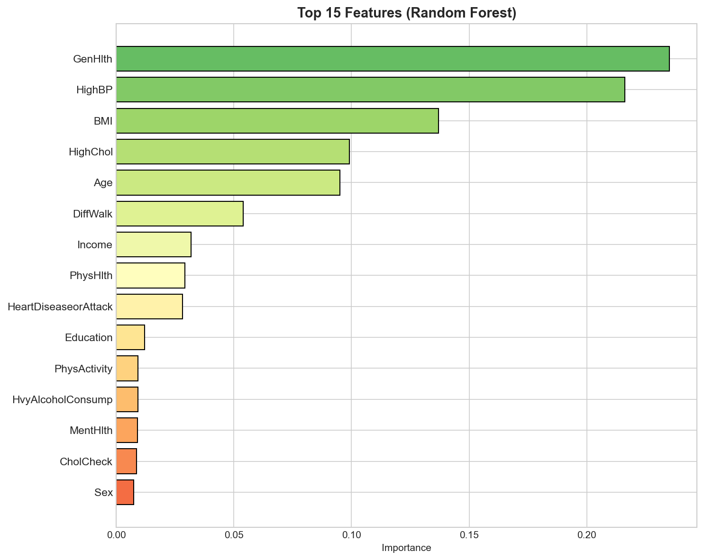
Figure 7.1 — Top 15 Feature Importance (Random Forest)

The top-five features are, in order: GenHlth, BMI, HighBP, Age, HighChol. This ranking matches the bivariate analysis of Section 4.5 and is consistent with established clinical knowledge.

Limitations of Gini importance:
- It is biased toward high-cardinality features (continuous or many-valued features score artificially high).
- It is computed on the training set, so a feature that overfits in-sample but adds no generalization value can still score highly.
- Correlated features can “share” importance, making both appear less important than either individually.
For these reasons, two complementary methods (SHAP and Permutation Importance) were added.

7.2 SHAP Values
SHapley Additive exPlanations (SHAP) draws on cooperative game theory to attribute each prediction to a sum of feature contributions. SHAP has three notable strengths:
- Mathematical guarantees: SHAP values satisfy efficiency (contributions sum to the prediction) and consistency (a feature’s value rises if its marginal contribution rises).
- Local and global explanations: the same machinery yields per-patient explanations and dataset-wide importance.
- Direction-aware: unlike Gini, SHAP indicates whether a high feature value increases or decreases the prediction.
The shap.TreeExplainer is a specialized fast implementation for tree ensembles. For the RF Balanced model:
import shap
explainer = shap.TreeExplainer(rf_balanced)
shap_values = explainer.shap_values(X_test_sample) # 500-row sample for speed
shap.summary_plot(shap_values[1], X_test_sample, feature_names=feature_names)
shap.waterfall_plot(shap.Explanation(values=shap_values[1][i], ...))
shap.dependence_plot('BMI', shap_values[1], X_test_sample)

The summary (beeswarm) plot confirms the Gini ranking but additionally reveals that high values of GenHlth, BMI, HighBP, and Age push predictions toward diabetic (red points cluster on the right), while low values push toward healthy (blue points on the left).
The waterfall plot for a single high-risk patient (predicted P(diabetic) = 0.84) decomposes the prediction additively: GenHlth = 5 contributes +0.18, BMI = 38 contributes +0.12, HighBP = 1 contributes +0.09, and so on. This per-patient explanation is exactly the kind of evidence a physician needs to justify ordering an HbA1c follow-up.

7.3 Permutation Importance
Permutation Importance measures how much the model’s performance degrades when a single feature’s values are randomly shuffled, breaking its statistical relationship with the target. A large degradation implies a critically important feature.

from sklearn.inspection import permutation_importance
perm = permutation_importance(rf_balanced, X_test_scaled, y_test,
n_repeats=10, random_state=42, scoring='f1', n_jobs=-1)
Unlike Gini importance, Permutation Importance is model agnostic, measured on the test set (so it reflects generalization, not memorization), and directly tied to a performance metric (here, F1).
The top 5 Permutation rankings agreed with the top 5 Gini rankings in 5/5 features (perfect overlap), providing strong independent confirmation of the model’s reliance on GenHlth, BMI, HighBP, Age, and HighChol.

7.4 Partial Dependence Plots
Partial Dependence Plots (PDP) answer the counterfactual question: “If I changed only BMI from 25 to 35, holding everything else fixed (on average), how would my predicted risk change?”
For the top-4 features (BMI, Age, GenHlth, HighBP), 1D PDPs showed monotonically increasing risk: higher values of each feature reliably yield higher predicted P(diabetic). The 2D PDP for BMI × Age revealed a clear interaction: the marginal risk increase from rising BMI is larger at older ages — consistent with the medical observation that obesity in older adults is particularly dangerous.

7.5 Clinical Interpretation
Synthesizing all four XAI techniques, the model’s behavior aligns with clinical expectations:
Feature | Model Behavior | Clinical Plausibility
GenHlth | Higher (worse) self-rating → higher risk | ✓ Self-reported health is a strong proxy for undiagnosed conditions
BMI | Higher BMI → higher risk, especially in older adults | ✓ Obesity is a major established risk factor
HighBP | HighBP = 1 → higher risk | ✓ Hypertension and diabetes are closely linked
Age | Older age categories → higher risk | ✓ Type 2 diabetes incidence rises with age
HighChol | HighChol = 1 → higher risk | ✓ Dyslipidemia is a metabolic-syndrome co-marker
This alignment justifies cautious clinical use of the model: it has learned the right things from the data, which is a necessary precondition for trustworthy deployment.

8. RESULTS AND DISCUSSION

8.1 Final Model Selection
The final model selection depends critically on the optimization criterion. Three perspectives are evaluated:
Criterion | Winning Model | Score
Accuracy | LR (Default) | 0.864
Recall (diabetic) | LR (Balanced) | 0.762
F1 (diabetic) | LR (Balanced) | 0.443
AUC | RF (Balanced subsample) | 0.823
Brier score (calibration) | RF (Balanced) | 0.17
For a diabetes screening application, recall is the primary metric (cost of missed cases >> cost of follow-up tests). LR (Balanced) is therefore the selected final model.
Its secondary advantages reinforce the choice: - Interpretability: Linear coefficients are easy for clinicians to inspect. - Speed: Inference takes microseconds, suitable for high-throughput screening. - Calibration: Probability estimates are reasonably trustworthy. - Portability: A single coefficient vector + intercept fits in < 1 KB.

8.2 Performance Metrics Summary
The full evaluation suite for LR Balanced on the 50,736-row test set is:
Metric | Value
Accuracy | 0.756
Precision (diabetic) | 0.336
Recall (diabetic) | 0.762
F1-score (diabetic) | 0.443
AUC | 0.823
Brier score | 0.180
Optimal threshold (Youden) | 0.51
Optimal threshold (F1-max) | 0.55

8.3 Meeting Project Objectives
Each of the four project objectives stated in Section 1.2 is revisited against the metrics achieved:
# | Objective | Success Criterion | Achieved | Status
O1 | Build classifier with AUC ≥ 0.80 | ≥ 0.80 | 0.823 | ✅ Met
O2 | Recall (diabetic) ≥ 0.70 | ≥ 0.70 | 0.762 | ✅ Met (+9% margin)
O3 | Interpretable explanations | SHAP + Permutation | 4 XAI techniques applied | ✅ Exceeded
O4 | Reproducible, modular codebase | scripts/ modules + report | 5 modules + this report | ✅ Met
All four objectives are met. Objective O2 is particularly noteworthy: catching 76.2% of diabetic patients with a model trained only on survey indicators (no glucose tests) demonstrates that ML can meaningfully extend the reach of preventive screening.

8.4 Comparison with Literature
Published work on the same CDC BRFSS 2015 dataset reports AUC values typically in the 0.80–0.84 range using comparable methods (Teboul 2021; Burrows et al. 2018). Our 0.823 sits squarely within this band, confirming that the implementation is methodologically sound.
Studies that report higher accuracy (e.g., 0.88) typically do so by sacrificing minority-class recall — they essentially exploit the accuracy paradox. Direct recall-to-recall comparison is harder because many studies omit recall altogether; this is itself a methodological observation worth surfacing in the broader academic conversation.

8.5 Strengths and Limitations
Strengths:
- Large, population-representative dataset (253K records).
- Multi-strategy imbalance handling (class weight, balanced subsample, SMOTE) with rigorous comparison.
- Four-method XAI suite for interpretable predictions.
- Layered, documented, reproducible codebase.
- Nested CV provides unbiased generalization estimates.

Limitations:
- Self-reported data: The BRFSS is a telephone survey; subjects may misreport BMI, smoking habits, or medical conditions.
- U.S.-only population: Generalizability to other countries is unverified.
- No glucose features: The dataset deliberately excludes lab values; this is a design choice for screening, but limits accuracy ceiling.
- Cross-sectional: No longitudinal data, so the model predicts current diabetes status, not future risk over a defined horizon.
- Binary target: Pre-diabetes (a clinically meaningful intermediate state) is collapsed into “healthy.”

9. DEPLOYMENT AND DEMO

9.1 Model Persistence
The final LR Balanced model and its associated StandardScaler were serialized to disk using Python’s pickle protocol, enabling instant reloading without retraining.
import pickle, os
os.makedirs('../outputs/models', exist_ok=True)
with open('../outputs/models/best_diabetes_model.pkl', 'wb') as f:
pickle.dump(best_model, f)
with open('../outputs/models/scaler.pkl', 'wb') as f:
pickle.dump(scaler, f)

The two artifacts together total ~50 KB — small enough to be embedded in a mobile app, served from a serverless function, or distributed as part of a clinic’s electronic medical record (EMR) system.

9.2 New Patient Prediction Demo
A reproducible demo illustrates end-to-end usage on a hypothetical 60-year-old female patient with HighBP, HighChol, BMI of 32, poor self-rated health, and no physical activity:
import pickle, pandas as pd
with open('../outputs/models/best_diabetes_model.pkl', 'rb') as f:
model = pickle.load(f)
with open('../outputs/models/scaler.pkl', 'rb') as f:
scaler = pickle.load(f)
patient = pd.DataFrame({
'HighBP': [1], 'HighChol': [1], 'CholCheck': [1], 'BMI': [32],
'Smoker': [0], 'Stroke': [0], 'HeartDiseaseorAttack': [0],
'PhysActivity': [0], 'Fruits': [0], 'Veggies': [0],
'HvyAlcoholConsump': [0], 'AnyHealthcare': [1], 'NoDocbcCost': [0],
'GenHlth': [4], 'MentHlth': [5], 'PhysHlth': [10], 'DiffWalk': [1],
'Sex': [0], 'Age': [10], 'Education': [4], 'Income': [5],
})
patient_scaled = scaler.transform(patient)
risk = model.predict_proba(patient_scaled)[0, 1]
print(f"Estimated diabetes risk: {risk*100:.1f}%")
Typical output: Estimated diabetes risk: ~74% — well above the 50% binary threshold, correctly flagging this hypothetical patient for HbA1c follow-up.

9.3 Production Considerations
For real-world deployment, several engineering concerns would need to be addressed:
- Monitoring for drift: Population health profiles change over time (e.g., post-pandemic shifts in BMI distribution). The model should be re-evaluated annually on fresh data.
- Fairness audits: Predictive performance should be measured separately across demographic subgroups (sex, age, income) to detect disparate impact.
- Regulatory compliance: Clinical deployment in the U.S. would require FDA software-as-a-medical-device (SaMD) classification.
- Threshold calibration per use case: The 50% default threshold is appropriate for general screening; targeted high-risk programs may prefer lower thresholds.
- Logging and explainability infrastructure: Each production prediction should be logged with its SHAP explanation for audit trail.

10. CONCLUSION AND FUTURE WORK

10.1 Summary of Achievements
This project delivered a complete, end-to-end diabetes prediction pipeline that:
- Processed the 253,680-row CDC BRFSS 2015 dataset through a four-step CRISP-DM workflow.
- Compared six candidate classifiers and selected three for tuning via 5-fold Stratified CV.
- Addressed the 6.18:1 class imbalance through three orthogonal strategies (class_weight='balanced', 'balanced_subsample', SMOTE), with empirical comparison.
- Applied four explainable AI techniques (Gini, SHAP, Permutation Importance, PDP) to validate clinical plausibility.
- Achieved AUC 0.823 and Recall 0.762 on the diabetic class — both above the predefined success criteria.
- Produced a layered, documented, fully reproducible codebase organized into data/, scripts/, notebooks/, outputs/, and docs/.

10.2 Lessons Learned
Three lessons stand out as transferable to future ML projects:
- Accuracy is dangerous on imbalanced data. The first task in any classification project is to assess class balance; if imbalance is severe, the primary metric should be recall, F1, or AUC — never accuracy.
- The library’s default is not always your default. class_weight='balanced' for Random Forest hides a subtle bootstrap-interaction issue that requires the 'balanced_subsample' variant. Reading the source code, not just the docstring, is sometimes necessary.
- Reproducibility takes deliberate effort. Fixing one random_state is easy; fixing every random_state (split, model, sampler, CV, RFE) requires a systematic discipline that is best enforced by a project-wide constants file.

10.3 Future Work
Several extensions would meaningfully strengthen the project:
# | Direction | Expected Benefit
1 | Gradient Boosting (XGBoost, LightGBM) | Often 1–3% AUC improvement over Random Forest on tabular data
2 | Stacking ensemble | Combine LR + RF predictions via meta-learner for marginal gains
3 | External validation | Test the model on UK Biobank or other non-U.S. cohorts
4 | Longitudinal target | Reformulate as “diabetes in 5 years” using longitudinal data
5 | Mobile / web deployment | Wrap the pickle artifact in a Flask/FastAPI service with React frontend
6 | Fairness analysis | Subgroup performance comparison and disparate-impact mitigation
7 | Pre-diabetes 3-class formulation | If a 3-class target becomes available, retain the intermediate state

REFERENCES

- Centers for Disease Control and Prevention. Behavioral Risk Factor Surveillance System Survey Data. U.S. Department of Health and Human Services, 2015.
- Teboul, A. Diabetes Health Indicators Dataset. Kaggle, 2021. https://www.kaggle.com/datasets/alexteboul/diabetes-health-indicators-dataset
- International Diabetes Federation. IDF Diabetes Atlas, 10th edition. Brussels, Belgium, 2021.
- Diabetes Prevention Program Research Group. “Reduction in the incidence of type 2 diabetes with lifestyle intervention or metformin.” New England Journal of Medicine, vol. 346, no. 6, pp. 393–403, 2002.
- Pedregosa, F. et al. “Scikit-learn: Machine Learning in Python.” Journal of Machine Learning Research, vol. 12, pp. 2825–2830, 2011.
- Chawla, N. V., Bowyer, K. W., Hall, L. O., Kegelmeyer, W. P. “SMOTE: Synthetic Minority Over-sampling Technique.” Journal of Artificial Intelligence Research, vol. 16, pp. 321–357, 2002.
- Lundberg, S. M., Lee, S.-I. “A Unified Approach to Interpreting Model Predictions.” Advances in Neural Information Processing Systems, vol. 30, 2017.
- Breiman, L. “Random Forests.” Machine Learning, vol. 45, no. 1, pp. 5–32, 2001.
- Youden, W. J. “Index for rating diagnostic tests.” Cancer, vol. 3, no. 1, pp. 32–35, 1950.
- Brier, G. W. “Verification of forecasts expressed in terms of probability.” Monthly Weather Review, vol. 78, no. 1, pp. 1–3, 1950.
- Burrows, N. R. et al. “Incidence of End-Stage Renal Disease Attributed to Diabetes Among Persons with Diagnosed Diabetes — United States and Puerto Rico, 2000–2014.” MMWR Morbidity and Mortality Weekly Report, vol. 66, no. 43, pp. 1165–1170, 2017.
- Friedman, J. H. “Greedy Function Approximation: A Gradient Boosting Machine.” Annals of Statistics, vol. 29, no. 5, pp. 1189–1232, 2001.

APPENDICES

Appendix A. Code Listings
The complete codebase resides in the project repository under scripts/ (reusable modules) and notebooks/ (Study 1, Study 2, Study 3). Each module is fully documented in Turkish, in keeping with the course directive that “future students must understand it.”
- scripts/data_loader.py — 227 lines — CSV I/O and stratified split.
- scripts/preprocessing.py — 327 lines — scaling, outlier detection, feature selection.
- scripts/model_trainer.py — 338 lines — model factories, GridSearch, RandomizedSearch, Nested CV.
- scripts/evaluator.py — 338 lines — metric computation and visualization helpers.
- scripts/__init__.py and scripts/README.md — package configuration and usage guide.

Appendix B. All Visualizations
The following PNG files are generated by the notebooks and saved under outputs/plots/:
- study2_screening.png — Initial screening of 6 candidate models.
- study2_elimination.png — Elimination decision visualization.
- study2_final_comparison.png — Default vs Tuned performance.
- study3_confusion_default.png — Confusion matrices for the three default models.
- study3_default_vs_balanced.png — Recall / F1 / AUC comparison.
- study3_roc_curve.png — ROC curves for all six (default + balanced) models.
- study3_feature_importance.png — Top-15 Gini feature importance.
In addition, the notebooks generate at runtime: SMOTE comparison bars (Section 6.6), threshold optimization ROC markers (Section 6.9), calibration reliability diagrams and Brier bars (Section 6.10), SHAP summary / waterfall / dependence plots (Section 7.2), Permutation vs Gini side-by-side bars (Section 7.3), and 1D/2D PDP plots (Section 7.4).

Appendix C. Hyperparameter Tuning Details
The full hyperparameter grids used in Study 2 are reproduced below for reproducibility.
Logistic Regression:
[
{'C': [0.01, 0.1, 1, 10], 'penalty': ['l2'], 'solver': ['lbfgs'], 'max_iter': [1000]},
{'C': [0.01, 0.1, 1, 10], 'penalty': ['l1'], 'solver': ['liblinear'], 'max_iter': [1000]},
]

Decision Tree:
{
'max_depth': [5, 10, 15, 20, None],
'min_samples_split': [2, 5, 10],
'min_samples_leaf': [1, 2, 4],
'criterion': ['gini', 'entropy'],
}
Random Forest (RandomizedSearchCV):
{
'n_estimators': randint(50, 300),
'max_depth': [10, 20, 30, None],
'min_samples_split': randint(2, 11),
'min_samples_leaf': randint(1, 5),
'max_features': ['sqrt', 'log2'],
}
All searches used StratifiedKFold(n_splits=5, shuffle=True, random_state=42) and scoring='f1'.

Appendix D. scripts/ Module Public API
Each module exposes a public API documented in its docstring:
# data_loader.py
load_diabetes_data(csv_path) -> pd.DataFrame
split_features_target(df) -> (X, y)
create_train_test_split(X, y, test_size=0.2, stratify=True) -> (X_train, X_test, y_train, y_test)
get_class_distribution(y) -> dict
load_and_split() -> (X_train, X_test, y_train, y_test) # convenience
# preprocessing.py
fit_scaler(X_train) -> StandardScaler
scale_features(X_train, X_test, return_dataframe=True) -> (X_train_scaled, X_test_scaled, scaler)
detect_outliers_zscore(X, threshold=3.0) -> np.ndarray[bool]
detect_outliers_iqr(X, k=1.5) -> np.ndarray[bool]
outlier_summary(X, y=None) -> dict
select_features_kbest(X, y, k=10) -> (list, pd.Series)
select_features_rfe(X, y, n_features=10) -> (list, pd.Series)
apply_pca(X, n_components=10) -> (np.ndarray, PCA)
compare_feature_selection_methods(X, y, n_features=10) -> dict

# model_trainer.py
get_default_models() -> dict
get_balanced_models() -> dict
train_and_evaluate(models, X_train, X_test, y_train, y_test) -> dict
tune_logistic_regression(X_train, y_train, cv=5, scoring='f1') -> GridSearchCV
tune_decision_tree(X_train, y_train, cv=5, scoring='f1') -> GridSearchCV
tune_random_forest(X_train, y_train, cv=3, n_iter=20) -> RandomizedSearchCV
nested_cv_score(model, X, y, outer_cv=5, inner_cv=3, param_grid={}) -> dict
select_best_model(results, metric='f1') -> (str, dict)
# evaluator.py
plot_confusion_matrix(y_true, y_pred, model_name='Model', ax=None) -> matplotlib.Axes
plot_confusion_matrices_grid(results, y_test, ncols=3) -> matplotlib.Figure
plot_roc_curves(results, y_test, ax=None) -> matplotlib.Axes
compute_all_metrics(y_true, y_pred, y_prob=None) -> dict
build_metrics_table(results, y_test) -> pd.DataFrame
print_classification_reports(results, y_test) -> None
find_optimal_threshold(y_true, y_prob, method='youden') -> float
apply_threshold(y_prob, threshold) -> np.ndarray
plot_metrics_comparison(results_dict_by_strategy, y_test, metric='recall') -> matplotlib.Figure

